Invited speakers
Kerim Allakhverdiyev (Division Leader at the National Aviation Academy, Baku, Azerbaijan)

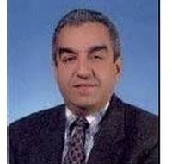

Dmitry Gitman (Sao Paulo University, San Paulo, Brazil and PN Lebedev Physical İnstitute of RAS, Moscow, Russia)

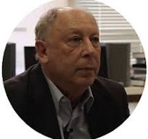

Said Safarov (H. Aliyev Geography Institute of the Ministry of Sciences and Education of the Azerbaijan Republic, Baku, Azerbaijan)

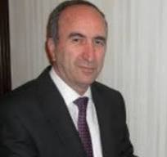

Shakhlar Askerov (Baku State University and State Economy University (UNEC) of the Ministry of Sciences and Education of the Azerbaijan Republic, Baku, Azerbaijan)
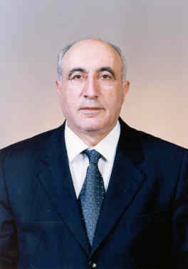

Maxim Dvornikov (Pushkov Institute of Terrestrial Magnetism, Ionosphere and Radio Wave Propagation Russian Academy of Sciences (IZMIRAN), Moscow, Troitsk, Russia)

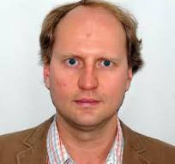

Anzor Khelashvili, (Nodar Amaglobeli High Energy Physics Institute (HEPI) of the İvane Muskhelishvili Tbilisi State Univrsity (TSU), Tbilisi, Georgia)

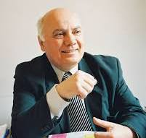

Arshad Saleem Bhatti (Pakistan Virtual University and COMSAT, Islamabad, Pakistan)

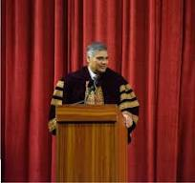

Emin Garibli (State Economy University (UNEC) of the Ministry of Sciences and Education of the Azerbaijan Republic, Baku, Azerbaijan)
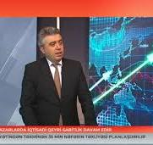

Sohrab Rahvar (Sharif Technology University, Tehran, Iran)

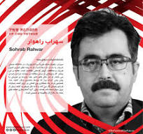

Raşit Ahiska (TES Thermoelectric Systems Energy R&D Production Marketing Distribution Consultancy Education Manufacturing Industry and Trade Limited Company, Turkey)
